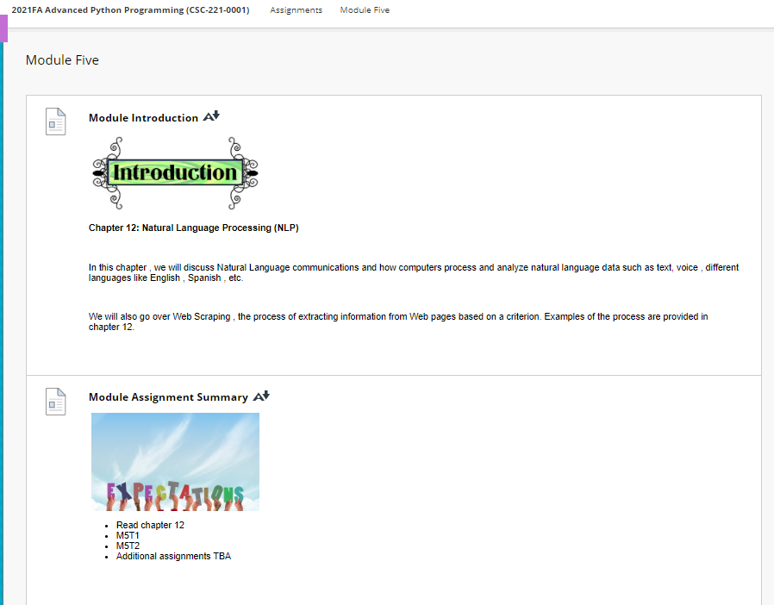

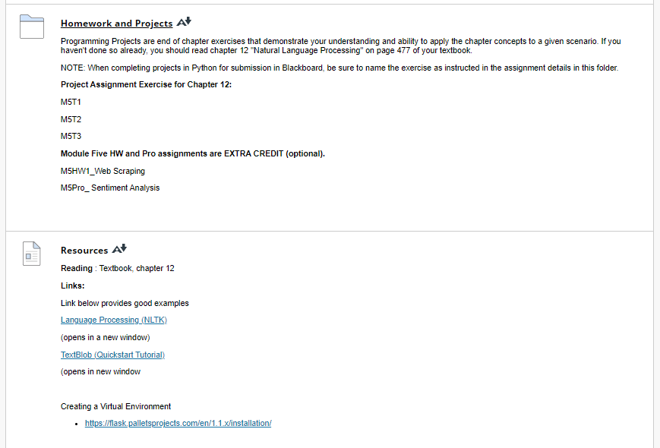

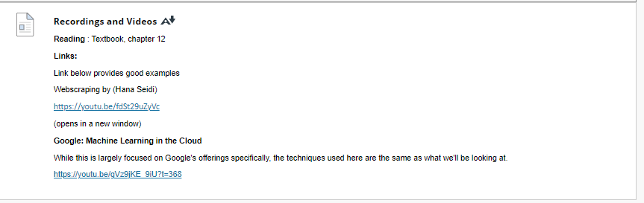

**Resources**

[Resources](https://faytechcc.blackboard.com/webapps/blackboard/content/listContent.jsp?course_id=_35059_1&content_id=_5950141_1)

**Reading** : Textbook, chapter 12

**Links:**

Link below provides good examples

[Language Processing (NLTK)](https://www.nltk.org/book/ch01.html) <https://www.nltk.org/book/ch01.html>

(opens in a new window)

[TextBlob (Quickstart Tutorial)](https://textblob.readthedocs.io/en/dev/quickstart.html) <https://textblob.readthedocs.io/en/dev/quickstart.html>

(opens in new window

Creating a Virtual Environment

* <https://flask.palletsprojects.com/en/1.1.x/installation/>

### Recordings and Videos

[Recordings and Videos](https://faytechcc.blackboard.com/webapps/blackboard/content/listContent.jsp?course_id=_35059_1&content_id=_5950141_1)

**Reading** : Textbook, chapter 12

**Links:**

Link below provides good examples

Webscraping by (Hana Seidi)

<https://youtu.be/fdSt29uZyVc>

(opens in a new window)

**Google: Machine Learning in the Cloud**

While this is largely focused on Google's offerings specifically, the techniques used here are the same as what we'll be looking at.

<https://youtu.be/gVz9jKE_9iU?t=368>